A
Real-Time Research Project Report
On

IOT Based Disaster Response System
(Submitted in partial fulfillment of the requirements for the award of Degree)

BACHELOR OF TECHNOLOGY
In

COMPUTER SCIENCE AND ENGINEERING (DATA SCIENCE)

By
Yashaswi Dasari (247R1A67E8)
B.Arun Kumar(247R1A67D7)
A.Sri Vamshi (247R1A67D4)
K.Gowtham Kumar (257R5A6717)

Under the Guidance of
V.Sandhya
Assistant Professor-CSE(DS)


DEPARTMENT OF COMPUTER SCIENCE AND ENGINEERING (DATA SCIENCE)
CMR TECHNICAL CAMPUS
UGC AUTONOMOUS
(Accredited by NAAC, NBA, Permanently Affiliated to JNTUH, Approved by AICTE, New Delhi)
Recognized Under Section 2(f) & 12(B) of the UGCAct.1956, Kandlakoya (V), Medchal Road, Hyderabad-501401.
April, 2026.

DEPARTMENT OF COMPUTER SCIENCE AND ENGINEERING (DATA SCIENCE)



CERTIFICATE

This is to certify that the project entitled “IOT Based Disaster Response System” being submitted by Yashaswi Dasari (247R1A67E8), B.Arun Kumar (247R1A67D7), A.Sri Vamshi (247R1A67D4), K.Gowtham Kumar (257R5A6717) in partial fulfillment of the requirements for the award of the degree of B.Tech in Computer Science and Engineering to the Jawaharlal Nehru Technological University Hyderabad, during the year 2025-2026.

The results embodied in this thesis have not been submitted to any other University or Institute for the award of any degree or diploma.

V.Sandhya Dr. K. Murali
Assistant Professor HoD-CSE(DS)
INTERNAL GUIDE


CMR TECHNICAL CAMPUS

UGC AUTONOMOUS

(Accredited by NAAC, NBA, Permanently Affiliated to JNTUH, Approved by AICTE, New Delhi)
Recognized Under Section 2(f) & 12(B) of the UGCAct.1956, Kandlakoya (V), Medchal Road, Hyderabad-501401.

Department of CSE [Data Science]

Program Specific Outcomes (PSOs):

PSO-1: Apply the principles and conduct investigations in data science for sustainable development.

PSO-2: Explore data science research and applications to solve industry and societal challenges.

PSO-3: Promote communication, ethics, and lifelong learning with a focus on social responsibility.

Program Educational Objectives (PEOs):

PEO-1: Graduates will have the ability to apply data science techniques to develop innovative solutions for real-world problems.

PEO-2: Graduates will have the ability to pursue research and higher education in the data science and aligned fields.

PEO-3: Graduates will have the ability to become ethically driven leaders and innovative entrepreneurs in data science domain.


CMR TECHNICAL CAMPUS
UGC AUTONOMOUS
(Accredited by NAAC, NBA, Permanently Affiliated to JNTUH, Approved by AICTE, New Delhi)
Recognized Under Section 2(f) & 12(B) of the UGCAct.1956, Kandlakoya (V), Medchal Road, Hyderabad-501401.

Department of CSE [Data Science]

Institute Vision & Mission
Vision:
- To Impart quality education in serene atmosphere thus strive for excellence in Technology and Research.
Mission:
- To Create state of art facilities for effective Teaching- Learning Process.
- Pursue and Disseminate Knowledge based research to meet the needs of Industry
& Society.
- Infuse Professional, Ethical and Societal values among Learning Community.

Department Vision & Mission
Vision:
- To provide a quality education and research environment in Data Science that fosters innovation and technological advancement to meet global challenges.
Mission:
- To provide an industry-aligned data science curriculum to develop strong analytical and problem-solving skills.
- To foster a research-driven environment that promotes innovation and technological advancements.
To promote lifelong learning, teamwork and ethics for global challenges.


CMR TECHNICAL CAMPUS
UGC AUTONOMOUS
(Accredited by NAAC, NBA, Permanently Affiliated to JNTUH, Approved by AICTE, New Delhi)
Recognized Under Section 2(f) & 12(B) of the UGCAct.1956, Kandlakoya (V), Medchal Road, Hyderabad-501401.

Department of CSE [Data Science]

Program Outcomes (POs):

PO1: Engineering Knowledge: Apply knowledge of mathematics, natural science, computing, engineering fundamentals and an engineering specialization to develop to the solution of complex engineering problems.
PO2: Problem Analysis: Identify, formulate, review research literature and analyze complex engineering problems reaching substantiated conclusions with consideration for sustainable development.
PO3: Design/Development of Solutions: Design creative solutions for complex engineering problems and design/develop systems/components/processes to meet identified needs.
PO4: Conduct Investigations of Complex Problems: Conduct investigations of complex engineering problems using research-based knowledge.
PO5: Engineering Tool Usage: Create, select and apply appropriate techniques, resources and modern engineering & IT tools.
PO6: The Engineer and The World: Analyze and evaluate societal
and environmental aspects while solving complex engineering problems.
PO7: Ethics: Apply ethical principles and commit to professional ethics, human values, diversity and inclusion.
PO8: Individual and Collaborative Team work: Function effectively as an individual, and as a member or leader in diverse teams.
PO9: Communication: Communicate effectively within the engineering community and society.
PO10: Project Management and Finance: Apply knowledge of engineering management principles and economic decision-making.
PO11: Life-LongLearning: Recognize the need for independent and life-long learning

ACKNOWLEDGEMENT

We take this opportunity to express our gratitude to the people who have been instrumental in the successful completion of this project, we take this opportunity to express our profound gratitude and deep regard to our guide V.Sandhya, Assistant professor for her exemplary guidance, monitoring and constant encouragement throughout the project work. The blessing, help and guidance given by him/her shall carry us a long way in the journey of life on which we are about to embark.
We also take this opportunity to express a deep sense of gratitude to the Project Review Committee (PRC) coordinators A. Lakshman, Sanjib Kumar Nayak, for their cordial support, valuable information and guidance, which helped us in completing this task through various stages.
We are also thankful to Dr. K. Murali, Head, Department of Computer Science and Engineering (Data Science) for providing encouragement and support for completing this project successfully.
We are deeply grateful to Dr. A. Raji Reddy, Director, for his cooperation throughout the course of this project. Additionally, we extend our profound gratitude to Sri. Ch. Gopal Reddy, Chairman, Smt. C. Vasantha Latha, Secretary and Sri. C. Abhinav Reddy, Vice-Chairman, for fostering an excellent infrastructure and a conducive learning environment that greatly contributed to our progress.
The guidance and support received from all the members of CMR Technical Campus who contributed to the completion of the project. We are grateful for their constant support and help.
Finally, we would like to take this opportunity to thank our family for their constant encouragement, without which this assignment would not be completed. We sincerely acknowledge and thank all those who gave support directly and indirectly in the completion of this project.

Yashaswi Dasari (247R1A67E8)
B.Arun Kumar(247R1A67D7)
A.Sri Vamshi (247R1A67D4)

K.Gowtham Kumar (257R5A6717)

ABSTRACT

Natural disasters such as earthquakes and extreme temperature conditions pose serious threats to human life and infrastructure. Early detection and timely alerts are critical for reducing damage and improving emergency response. This project presents an IoT Based Disaster Response System using ESP32 microcontroller, DHT11 temperature sensor, gyroscope sensor, buzzer alert, and Blynk IoT platform.The system continuously monitors environmental temperature and detects abnormal vibrations or tilts indicating possible earthquake activity using a gyroscope sensor. When the temperature exceeds a predefined safety threshold or seismic activity is detected, the ESP32 immediately activates a buzzer alarm and sends real-time alert notifications to users via the Blynk IoT mobile application. This enables quick evacuation and precautionary actions.The proposed system is cost-effective, reliable, and suitable for smart buildings, industrial safety systems, and disaster-prone regions.

TABLE OF CONTENTS

ABSTRACT |  |  |  | i
LIST OF FIGURES |  |  |  | ii
LIST OF TABLES |  |  |  | v
1. | INTRODUCTION |  |  | 1
 | 1.1 | PROJECT PURPOSE |  | 1
 | 1.2 | PROJECT FEATURES |  | 2
2. | LITERATURE SURVEY |  |  | 3
 | 2.1 | REVIEW OF RELATED WORK |  | 6
 | 2.2 | DEFINITION OF PROBLEM STATEMENT |  | 8
 | 2.3 | EXISTING SYSTEM |  | 8
 | 2.4 | PROPOSED SYSTEM |  | 9
 | 2.5 | OBJECTIVES |  | 10
 | 2.6 | HARDWARE & SOFTWARE REQUIREMENTS |  | 12
 |  | 2.6.1 | HARDWARE REQUIREMENTS | 12
 |  | 2.6.2 | SOFTWARE REQUIREMENTS | 12
3. | SYSTEM ARCHITECTURE & DESIGN |  |  | 14
 | 3.1 | PROJECT ARCHITECTURE |  | 14
 | 3.2 | DESCRIPTION |  | 16
 | 3.3 | DATA FLOW DIAGRAM |  | 17
4. | IMPLEMENTATION |  |  | 20
 | 4.1 | ALGORITHMS USED |  | 20
 | 4.2 | SAMPLE CODE |  | 28
5. | RESULTS & DISCUSSION |  |  | 37
6. | VALIDATION |  |  | 47
 | 6.1 | INTRODUCTION |  | 47
 | 6.2 | TEST CASES |  | 48
 |  | 6.2.1 | UPLOADING DATASET | 48
 |  | 6.2.2 | CLASSIFICATION | 48
7. | CONCLUSION & FUTURE ASPECTS |  |  | 49
 | 7.1 | PROJECT CONCLUSION |  | 49
 | 7.2 | FUTURE ASPECTS |  | 50
8. | BIBLIOGRAPHY |  |  | 51
 | 8.1 | REFERENCES |  | 51
 | 8.2 | GITHUB LINK |  | 53

LIST OF FIGURES

FIGURE NO | FIGURE NAME | PAGE NO
Figure 3.1 | Project architecture based on IoT disaster response system. | 15
Figure 3.2  Figure 4.1  Figure 4.2  Figure 4.3  Figure 4.4  Figure 4.5  Figure 4.6 | Dataflow diagram of IoT disaster response system  Esp 32 microcontroller  DHT11-Temperature and humidity sensor  Gyro Sensor  Fire/Flame sensor  Lcd display  buzzer | 18  20  21  23  24  24  25
Figure 4.7 | Launch Arduino IDE.After your Arduino IDE software is downloaded. | 26
Figure 4.8 | Open an existing project example. to create a new project,select file ->New.to open | 26
Figure 4.9 | Select your Arduino board. | 27
Figure 5.1 | Project interface of IoT disaster response system. | 37
Figure 5.2 | The kit will turn on of IoT disaster response system. | 38
Figure 5.3 | Connect the wifi then the kit will work of IoT disaster response system. | 39
Figure 5.4 | Temperature levels to show in IOT disaster response system. | 40
Figure 5.5 | LCD display to show the fire reading in IoT Disaster response system. | 41
Figure 5.6 | Alert Message of IoT disaster response system. | 42
Figure 5.7 | Overall projects kit of IoT disaster response system. | 43
Figure 5.8 | Gyro sensor alert message of earth quake of IoT disaster response system. | 44

LIST OF TABLES

TABLE NO | TABLE NAME | PAGE NO
Table 6.2.1 | Uploading Dataset | 48
Table 6.2.2 | Classification | 48

INTRODUCTION

INTRODUCTION

Disaster management has become a critical area of focus due to the increasing impact of natural hazards such as earthquakes, fires, and extreme temperature conditions. These events can occur suddenly and often lead to severe damage to life and property if not identified at an early stage. Therefore, there is a strong need for systems that can continuously monitor environmental conditions and provide timely warnings.

The advancement of embedded systems and IoT (Internet of Things) technologies has enabled the development of smart and automated monitoring solutions. By integrating sensors with microcontrollers, it is possible to collect real-time data and respond instantly to abnormal situations. Such systems reduce human dependency and improve the speed and accuracy of disaster detection.

In this project, an IoT-based disaster response system is developed using the ESP32 microcontroller. It utilizes sensors to monitor key environmental parameters such as temperature and motion. When unusual conditions are detected, the system generates alerts to warn users both locally and remotely.

This system aims to enhance safety by providing a reliable and efficient method for early detection and alert generation. It can be implemented in various environments including residential buildings, industries, and areas prone to natural disasters, thereby improving overall emergency preparedness.

PROJECT PURPOSE

To design and develop a real-time IoT-based disaster response system using ESP32.
To detect abnormal environmental conditions like high temperature and seismic activity (vibrations/tilts).
To provide early warning alerts through a buzzer and mobile notifications (Blynk app).
To help in quick evacuation and precautionary actions, reducing risk to human life and infrastructure.
To create a system that is cost-effective, reliable, and suitable for disaster-prone areas, smartbuildings , and industrial safety.

.

PROJECT FEATURES

Real-time monitoring of environmental conditions using sensors.
Temperature detection using DHT11 sensor.
Earthquake/seismic detection using gyroscope sensor (vibrations/tilts).
Immediate alert system using a buzzer for local warning.
Remote notifications sent to users via Blynk IoT mobile application.
Wi-Fi connectivity using ESP32 for cloud communication.
Continuous data monitoring and threshold comparison.
Early warning system for quick evacuation and safety measures.
Cost-effective and reliable design.
Suitable for smart buildings, industrial safety systems, and disaster-prone regions

LITERATURE REVIEW

2. LITERATURE REVIEW

"IoT Based Disaster Management System"

Ramesh Kumar, Anil Singh
This paper presents an IoT-based disaster management system using sensors and microcontrollers to detect abnormal environmental conditions. Data is transmitted to cloud platforms for real-time monitoring. The authors emphasize its role in reducing disaster impact by providing early alerts and enabling quick evacuation. The system is tested in earthquake-prone regions and shows promising results.

"Smart Earthquake Detection Using IoT"

Priya Sharma, Neha Gupta
The study proposes an IoT-based earthquake detection system using gyroscope and vibration sensors. The system alerts users through mobile applications when seismic activity is detected. The authors highlight its cost-effectiveness and applicability in urban areas. The system reduces dependency on traditional seismic monitoring stations and provides localized alerts.

"IoT Enabled Emergency Response System"

S. Patel, R. Mehta
This research integrates IoT with emergency response systems using ESP32 and cloud platforms. Sensors monitor temperature and vibrations, while alerts are sent to users via mobile applications. The authors demonstrate its scalability for industrial safety and smart buildings. The system enhances preparedness and minimizes human error during disasters.

"Cloud Integrated Disaster Monitoring"

Alok Jadhav, Vrishali Desai
The paper focuses on cloud integration for disaster monitoring systems. Sensor data is transmitted to cloud servers for storage, visualization, and predictive analysis. The system enables remote monitoring and supports large-scale deployment. The authors highlight its importance in disaster-prone regions and its contribution to effective emergency response.

"IoT Based Seismic Activity Monitoring"

Rakshita MB, Siddharth Sharma
This study presents an IoT-based system for monitoring seismic activity using gyroscope sensors. The system connects to the Blynk IoT platform for real-time alerts and notifications. The authors emphasize its role in reducing disaster impact by enabling quick evacuation. The system is tested in simulated earthquake conditions and proves effective in early detection.
“Design of Disaster Management System using IoT Based Interconnected Network with Smart City Monitoring”
Prabodh Sakhardande, Sumeet Hanagal, Savita Kulkarni.
IoT deals with intricate systems that integrate multiple disperse components towards their synergetic use. In this paper a system of interconnected smart modules is developed as a way to enable centralized data acquisition as well as provide an interlinked network for transmission of data in absence of any existing infrastructure. Emphasis is given on how sensing and communication technologies of IoT can effectively be used in smart city monitoring as well as in case of disaster management. The hardware of the module used for this purpose is studied and elaborated in a detailed manner.
“Design of early warning flood detection system for developing countries,”
- Basha, et al
In developing countries, flooding due to natural disasters such as hurricanes and earthquakes results in massive loss of life and property. Warning communities of the incoming flood provides an effective solution to this by giving people sufficient time to evacuate and protect their property. However, the range of early warning system solutions introduces a tangle of conflicting requirements including cost and reliability, and creates several interesting problems from factors as diverse as technological, social, and political. The complexity of these systems and need for autonomy within the context of a developing country while remaining maintainable and accessible by non-technical personnel provides a challenge not often solved within developed countries, much less the developing. After describing this problem, the paper discusses a proposed solution for the problem, initial experiments in implementing the solution, and lessons learned through that work.

”SMS Disaster Alert System Programming,”
- Cioca, et al.
Floods are natural phenomena that profoundly affect the development of human society, as they are the most widespread disasters in the world and they cause the greatest property and human loss. The flood warning system presented in this paper provides a reliable and effective solution, which is complementary to existing traditional warning systems; it employs information and communication technology and specialized devices.

REVIEW OF RELATED WORK

The development of IoT-based disaster response systems has gained significant
attention in the fields of embedded systems, wireless communication, and smart
monitoring. Various approaches have been proposed to detect and respond to disasters
such as fire, gas leakage, and environmental hazards. This section reviews existing
methods, highlighting their advantages and limitations.

    - Traditional Content Moderation Approaches

Early disaster detection systems relied on manual monitoring and alarm-based systems. These systems used basic sensors and human supervision to detect hazards like fire or gas leakage. Although simple and cost-effective, these approaches were not efficient for real-time monitoring and lacked automation, making them unreliable during emergency situations.

    - Microcontroller-Based Approaches

With the advancement of embedded systems, microcontrollers such as Arduino and ESP32 were used to automate disaster detection. These systems integrated sensors like temperature, gas, and flame sensors to detect abnormal conditions and trigger alarms.
While these systems improved automation, they were limited in terms of:
- Remote monitoring
- Data storage
- Scalability

    - IoT-Based Monitoring Approaches

Recent developments introduced IoT-based disaster monitoring systems, enabling real-time data transmission over the internet. These systems use Wi-Fi-enabled controllers like ESP32 to send sensor data to cloud platforms or mobile applications such as Blynk.
IoT systems provide:
- Real-time monitoring
- Remote alerts
- Continuous data tracking
However, challenges include network dependency and data security concerns.

    - AI and Smart Detection Approaches

Advanced systems integrate Artificial Intelligence and Machine Learning to predict disasters based on sensor data patterns. Techniques such as classification algorithms and anomaly detection models improve accuracy and reduce false alarms.
Despite improved performance, these systems require:
- Large datasets
- High computational resources
- Complex implementation

However, these models require massive computational resources and extensive pre- training on large datasets.

    - Comparison with the Proposed Approach

Existing systems have improved disaster detection, but limitations remain in real-time response, accuracy, and cost. The proposed IoT Disaster Response System overcomes these issues by combining sensor-based monitoring with efficient processing using ESP32.
Compared to traditional systems, the proposed system:
- Provides real-time alerts
- Improves reliability and response time
- Is cost-effective and easy to deploy
- Supports mobile monitoring via Blynk

DEFINITION OF PROBLEM STATEMENT
Natural disasters result in significant human and property loss.
Delay in detecting abnormal environmental conditions increases damage.
Need for localized real-time monitoring systems.
Requirement for both local and remote alert mechanisms.
Proposed solution: Development of a real-time IoT-based early warning and alert system.

EXISTING SYSTEM

Conventional disaster monitoring systems rely on centralized monitoring stations and expensive equipment. These systems often provide delayed alerts and are not easily accessible to the general public.

- High installation and maintenance cost
- Limited coverage in remote areas
- Delayed warning alerts
- Lack of real-time user notifications
- Dependence on centralized infrastructure

2.3.1 Limitations of Existing System
Depends on stable Wi-Fi connectivity for remote alerts.

Limited to specific sensors (temperature & vibration only).

Possibility of false alarms due to sensor sensitivity.

Accuracy affected by sensor calibration.

Cannot predict disasters, only detects early signs.

Power dependency – system fails during power outages.

Limited coverage area (not suitable for large-scale monitoring).

Requires periodic maintenance and updates.

PROPOSED SYSTEM

The proposed system is a compact and cost-effective IoT-based disaster response system designed to provide early detection and real-time alerts during natural disasters such as earthquakes and extreme temperature conditions.

The system uses an ESP32 microcontroller as the central processing unit, which is connected to multiple sensors. The DHT11 sensor continuously monitors the surrounding temperature, while the gyroscope sensor detects abnormal vibrations, tilts, or movements that may indicate seismic activity.

All sensor data is continuously collected and processed by the ESP32. The readings are compared with predefined threshold values to identify unsafe conditions. If the temperature exceeds the safe limit or unusual vibrations are detected, the system immediately responds by:

Activating a buzzer for local alert

Sending real-time notifications to users via the Blynk IoT mobile application

The system uses Wi-Fi connectivity to transmit data to the cloud, enabling remote monitoring and instant alerts. This ensures that users can take quick preventive actions such as evacuation.

Overall, the proposed system is:

Low-cost and efficient.

Provides dual alert mechanism (local + remote).

Suitable for smart buildings, industries, and disaster-prone areas.

Designed for reliability and quick.

2.4.1 Advantages of the Proposed System:
- Real-time monitoring
Continuously tracks temperature and vibrations without delay.

- Early detection
Identifies abnormal conditions before they become dangerous.

- Instant alerts
Sends quick warnings through buzzer and mobile notifications.

- Low-cost system
Uses affordable components like ESP32 and basic sensors.

- Easy installation & maintenance
Simple setup and minimal technical effort required.

- Remote monitoring (IoT)
Users can check alerts from anywhere using the Blynk app.

- Compact & portable
Small in size, easy to place in different locations.

- Improves safety
Helps reduce damage by enabling faster response.

- Energy efficient
Consumes less power, suitable for long-term use.

- Wide application
Can be used in homes, industries, and disaster-prone areas.

OBJECTIVES

The primary objective of the IoT-Based Disaster Response System is to design and develop a real-time monitoring and alert solution using the ESP32 microcontroller to enhance safety during natural disasters such as earthquakes and extreme temperature events. The system aims to provide early detection of abnormal environmental conditions to minimize risk to human life and infrastructure.
Another key objective is to monitor critical parameters, including environmental temperature using a DHT11 and abnormal vibrations or tilts using a gyroscope sensor, to detect possible seismic activity or hazardous temperature changes. The project also aims to generate immediate local alerts through a buzzer to warn nearby individuals and provide remote notifications via the Blynk IoT application.
Overall, the objectives are to enable timely disaster alerts, support rapid evacuation and precautionary measures, and provide a cost-effective and reliable system suitable for smart buildings, industrial safety setups, and disaster-prone regions.

HARDWARE & SOFTWARE REQUIREMENTS

    - HARDWARE REQUIREMENTS:

ESP32 Microcontroller
Acts as the main controller to process sensor data and manage communication.
DHT11 Temperature Sens or 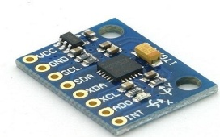
Measures ambient temperature continuously.

Gyroscope Sensor (e.g., MPU6050)
Detects vibrations, tilt, and motion indicating seismic activity.

Buzzer
Provides immediate local alert during abnormal conditions.

LCD Display (Optional)
Displays real-time sensor values and system status.

Wi-Fi Module (built-in ESP32)
Enables communication with Blynk IoT platform.

Power Supply (Battery/Adapter)
Provides required power for system operation.

Jumper Wires & Breadboard
Used for circuit connections and prototyping.

    - SOFTWARE REQUIREMENTS:

Arduino IDE
Used to write, compile, and upload code to ESP32.

Embedded C / Arduino Programming
Programming language used to control sensors and logic.

Blynk IoT Platform
Used for remote monitoring and sending mobile notifications.

Blynk Mobile Application
Displays real-time data and alerts to users.

ESP32 Board Package
Required to configure ESP32 in Arduino IDE.

Sensor Libraries (DHT11, MPU6050)
Help in reading data from temperature and gyroscope sensors.

Wi-Fi Drivers/Support
Enables ESP32 to connect to internet for cloud communication.

SYSTEM ARCHITECTURE & DESIGN

SYSTEM ARCHITECTURE & DESIGN

The proposed IoT-based disaster response system is designed with a structured architecture that enables continuous monitoring, data processing, and real-time alert generation. The system begins with the sensing layer, where the DHT11 temperature sensor and the gyroscope sensor are used to collect environmental data. The DHT11 measures the ambient temperature, while the gyroscope detects vibrations and orientation changes that may indicate seismic activity.
The collected data is then transmitted to the ESP32 microcontroller, which acts as the core processing unit of the system. The ESP32 continuously analyses the incoming sensor data and compares it with predefined threshold values to determine whether the conditions are safe or abnormal.
If the system detects any abnormality, such as a rise in temperature beyond the safe limit or unusual vibrations, it immediately triggers a buzzer to provide a local alert. At the same time, the ESP32 uses its built-in Wi-Fi capability to send the data to the Blynk IoT cloud platform. This allows remote monitoring and ensures that alert notifications are instantly delivered to the user’s mobile application.
Thus, the system architecture integrates sensing, processing, communication, and alert mechanisms into a unified framework, ensuring timely detection and rapid response to potential disaster situations.

PROJECT ARCHITECTURE

This project architecture shows the procedure followed Inappropriate Content Detection and Classification of YouTube Videos, starting from input to final prediction.
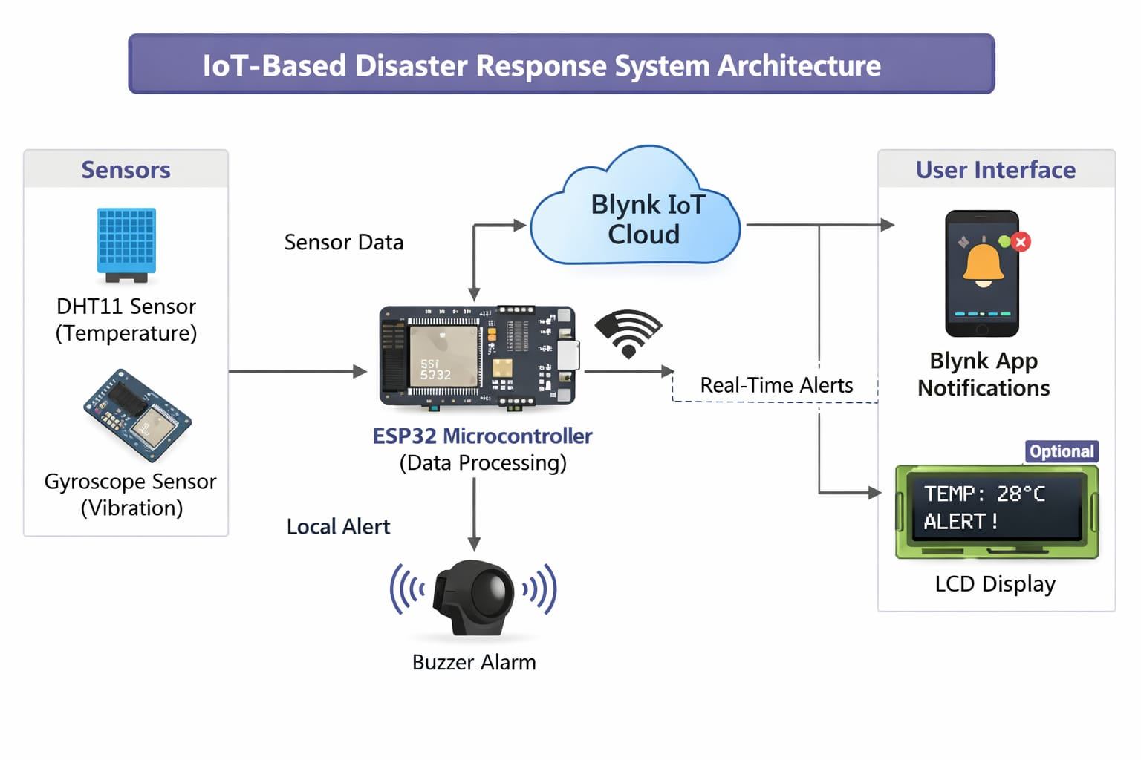

Figure 3.1: project architecture based on IOT disaster response system

DESCRIPTION

The proposed system is an IoT-based disaster response solution designed to monitor environmental conditions and provide early warnings during critical situations. It consists of sensors, a microcontroller, communication modules, and alert mechanisms working together as an integrated system.
The DHT11 temperature sensor continuously measures the surrounding temperature, while the gyroscope sensor detects vibrations and sudden movements that may indicate seismic activity. These sensors send real-time data to the ESP32 microcontroller, which acts as the brain of the system.
The ESP32 processes the incoming data and compares it with predefined safety thresholds. If any abnormal condition is detected, such as excessive temperature or unusual vibrations, the system immediately activates a buzzer to alert nearby individuals. At the same time, it sends real-time notifications to users through the Blynk IoT platform using Wi-Fi connectivity.
This system ensures both local and remote monitoring, allowing users to respond quickly to potential disasters. Due to its low cost, compact design, and efficient performance, it can be easily deployed in homes, industries, and disaster-prone areas to enhance safety and reduce risks.

DATA FLOW DIAGRAM

The data flow of the proposed IoT-based disaster response system begins with the input stage, where the DHT11 temperature sensor and the gyroscope sensor continuously collect environmental data such as temperature values and vibration or tilt information. This raw data is then transmitted to the ESP32 microcontroller, which acts as the central processing unit of the system.

The ESP32 processes the incoming data and performs analysis by comparing the sensor readings with predefined threshold values. This step determines whether the environmental conditions are normal or indicate a potential disaster situation. If the values remain within safe limits, the system continues monitoring without triggering any alerts.

However, when the processed data exceeds the set thresholds, indicating abnormal conditions such as high temperature or seismic activity, the system generates outputs in two forms. Firstly, a buzzer is activated to provide an immediate local alert to nearby individuals. Secondly, the ESP32 sends the processed data through Wi-Fi to the Blynk IoT cloud platform.

From the cloud platform, the information is delivered to the user’s mobile application in the form of real-time notifications. This ensures that users are informed instantly, even if they are not physically near the system. Thus, the data flow diagram represents a continuous cycle of data collection, processing, decision-making, and alert generation, enabling efficient and timely disaster response.

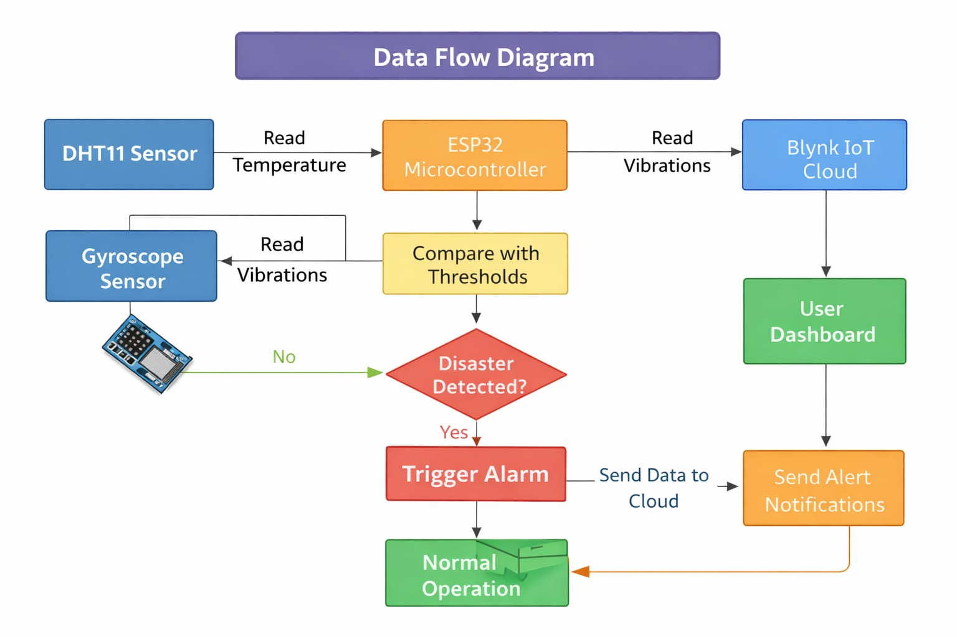

Figure 3.2: Dataflow Diagram of IoT Disaster response system

IMPLEMENTATION

IMPLEMENTATION
The system is implemented by connecting the DHT11 temperature sensor and gyroscope sensor to the ESP32 microcontroller. The ESP32 is programmed using Arduino IDE to continuously read and process sensor data. The readings are compared with predefined threshold values to detect abnormal conditions. When a threshold is exceeded, the buzzer is activated for local alert. At the same time, the ESP32 sends real-time data to the Blynk IoT platform via Wi-Fi, allowing users to receive instant notifications on their mobile devices. The system is tested and calibrated to ensure accurate and reliable performance

4.1 ALGORITHMS USED

4.1.1 ESP32 MICROCONTROLLER
ESP32 is the SoC (System on Chip) microcontroller which has gained massive popularity recently. Whether the popularity of ESP32 grew because of the growth of IoT or whether IoT grew because of the introduction of ESP32 is debatable. If you know 10 people who have been part of the firmware development for any IoT device, chances are that 7−8 of them would have worked on ESP32 at some point. So what is the hype all about? Why has ESP32 become so popular so quickly? Let's find out.
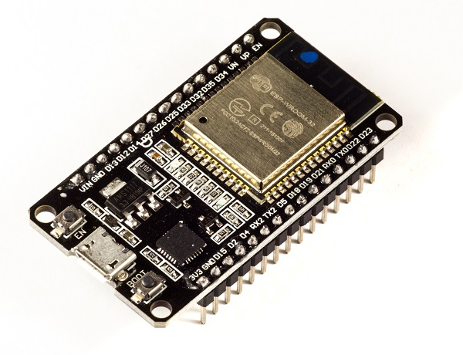
Figure 4.1:Esp 32 microcontroller

Advantages of ESP32 Models:

• Low cost and high performance
• Built-in Wi-Fi and Bluetooth
• Low power consumption modes
• Versatile and flexible
• Strong community support

Disadvantages of ESP32 Models:

• Complex for beginners
• Analog readings are less accurate
• Power consumption is higher in active Wi-Fi mode
• Requires proper power regulation

4.1.2 DHT11–TEMPERATURE AND HUMIDITY SENSOR

The DHT11 sensor can either be purchased as a sensor or as a module. Either way, the performance of the sensor is same. The sensor will come as a 4-pin package out of which only three pins will be used whereas the module will come with three pins as shown above.
The only difference between the sensor and module is that the module will have a filtering capacitor and pull-up resistor inbuilt, and for the sensor, you have to use them externally if required.
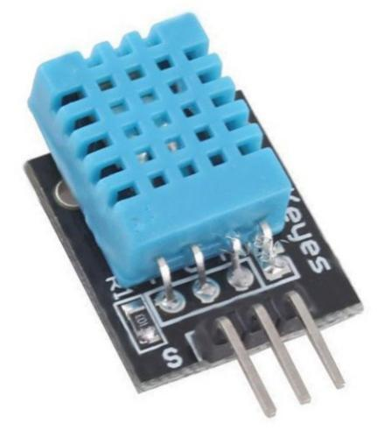

Firgure 4.2: DHT11-Temperature and humidity sensor

Where to use DHT11 Sensors
The DHT11 is a commonly used Temperature and humidity sensor. The sensor comes with a dedicated NTC to measure temperature and an 8-bit microcontroller to output the values of temperature and humidity as serial data. The sensor is also factory calibrated and hence easy to interface with other microcontrollers.
The sensor can measure temperature from 0°C to 50°C and humidity from 20% to 90% with an accuracy of ±1°C and ±1%.

Advantages of DHT11- TEMPERATURE AND HUMIDITY SENSOR:

- Low cost
- Easy interfacing with microcontrollers
- No need for external components
- Stable and reliable for basic use

Disadvantages of DTB11-TEMPERATURE AND HUMIDITY SENSOR:

- Low accuracy compared to advanced sensors
- Slow response time
- Limited range
- Not suitable for industrial applications

GYRO SENSOR

Besides sensing the angular velocity, Gyroscope sensors can also measure the motion of the object. For more robust and accurate motion sensing, in consumer electronics Gyroscope sensors are combined with Accelerometer sensors.
Depending on the direction there are three types of angular rate measurements. Yaw- the horizontal rotation on a flat surface when seen the object from above, Pitch- Vertical rotation as seen the object from front, Roll- the horizontal rotation when seen the object from front.
The concept of Coriolis force is used in Gyroscope sensors. In this sensor to measure the angular rate, the rotation rate of the sensor is converted into an electrical signal. Working principle of Gyroscope sensor can be understood by observing the working of Vibration Gyroscope sensor.
This sensor consists of an internal vibrating element made up of crystal material in the shape of a double – T- structure. This structure comprises a stationary part in the center with ‘Sensing Arm’ attached to it and ‘Drive Arm’ on both sides.
This double-T-structure is symmetrical. When an alternating vibration electrical field is applied to the drive arms, continuous lateral vibrations are produced. As Drive arms are symmetrical, when one arm moves to left the other moves to the right, thus canceling out the leaking vibrations. This keeps the stationary part at the center and sensing arm remains static.
When the external rotational force is applied to the sensor vertical vibrations are caused on Drive arms. This leads to the vibration of the Drive arms in the upward and downward directions due to which a rotational force acts on the stationary part in the center.
Rotation of the stationary part leads to the vertical vibrations in sensing arms. These vibrations caused in the sensing arm are measured as a change in electrical charge. This change is used to measure the external rotational force applied to the sensor as Angular rotation.

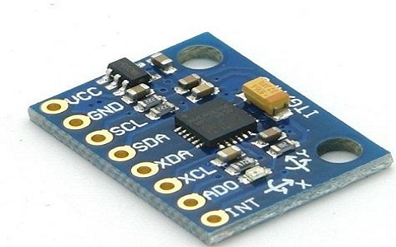

Figure 4.3: Gyro Sensor

FIRE SENSOR/ FLAME SENSOR:

A flame-sensor is one kind of detector which is mainly designed for detecting as well as responding to the occurrence of a fire or flame. The flame detection response can depend on its fitting. It includes an alarm system, a natural gas line, propane & a fire suppression system. This sensor is used in industrial boilers. The main function of this is to give authentication whether the boiler is properly working or not. The response of these sensors is faster as well as more accurate compare with a heat/smoke detector because of its mechanism while detecting the flame.
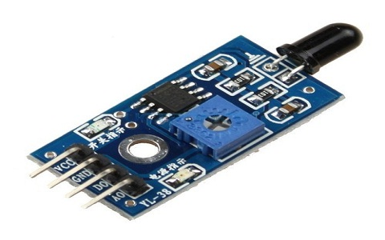

Figure 4.4: Fire/Flame sensor

4.1.5 LCD Interfacing:

The LCD can be interfaced to the microprocessor 8085 using the programmable peripheral interface (PPI-8255) IC. To display letters and numbers. ASCII code for the letters A to Z, a to 7, and numbers 0 to 9 is sent to the data lines (D0 -D7). These codes may be sent to LCD data lines through one port of 8255 (PPI), port A is used as the output port and send the data to the LCD. The EN pin and RS pin are connected to port B of the 8255. Since it is used as a normal display R/W is made low by connecting to the ground directly. Power supply connections are provided to Vcc and Vss pins. The Vee pin is connected to the EE moving node of the potentiometer which is connected between the Vcc and Vss pins. By moving the potentiometer the contrast of the LCD can be changed.

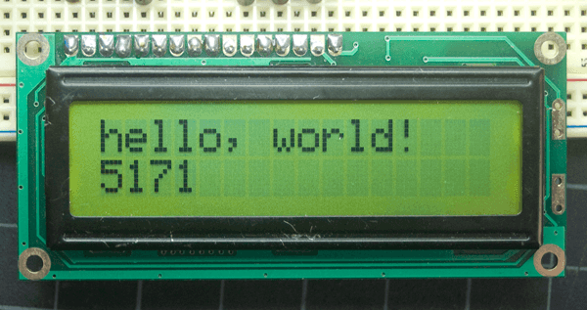

Figure 4.5: LCD display

BUZZER

An audio signalling device like a beeper or buzzer may be electromechanical or piezoelectric or mechanical type. The main function of this is to convert the signal from audio to sound. Generally, it is powered through DC voltage and used in timers, alarm devices, printers, alarms, computers, etc. Based on the various designs, it can generate different sounds like alarm, music, bell & siren.
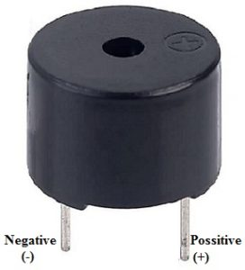

Figure 4.6: buzzer

Buzzer Pin Configuration
The pin configuration of the buzzer is shown below. It includes two pins namely positive and negative. The positive terminal of this is represented with the ‘+’ symbol or a longer terminal. This terminal is powered through 6Volts whereas the negative terminal is represented with the ‘-‘symbol or short terminal and it is connected to the GND terminal.

ARDUINO IDE :

Arduino is a prototype platform (open-source) based on an easy-to-use hardware and software. It consists of a circuit board, which can be programmed (referred to as a microcontroller) and a ready-made software called Arduino IDE (Integrated Development Environment), which is used to write and upload the computer code to the physical board.

KEY FEATURES OF ARDUINOIDE
Arduino boards are able to read analog or digital input signals from different sensors and turn it into an output such as activating a motor, turning LED on/off, connect to the cloud and many other actions.
You can control your board functions by sending a set of instructions to the microcontroller on the board via Arduino IDE (referred to as uploading software).
Unlike most previous programmable circuit boards, Arduino does not need an extra piece of hardware (called a programmer) in order to load a new code onto the board. You can simply use a USBcable.
Additionally, the Arduino IDE uses a simplified version of C++, making it easier to learn to program.Finally, Arduino provides a standard form factor that breaks the functions of the micro-controller into a more accessible package.
After learning about the main parts of the Arduino UNO board, we are ready to learn how to set up the Arduino IDE. Once we learn this, we will be ready to upload our program onthe Arduino board.
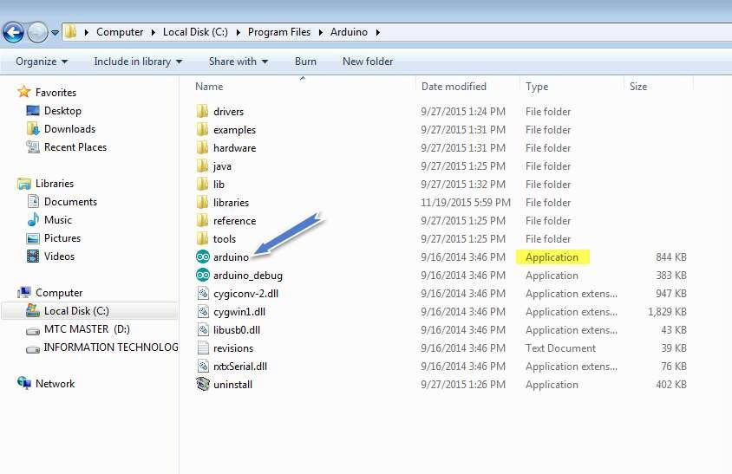
Figure 4.7: Launch Arduino IDE. After your Arduino IDE software is downloaded,

Figure 4.8: Open an existing project example.To create a new project, select File -->New.To open
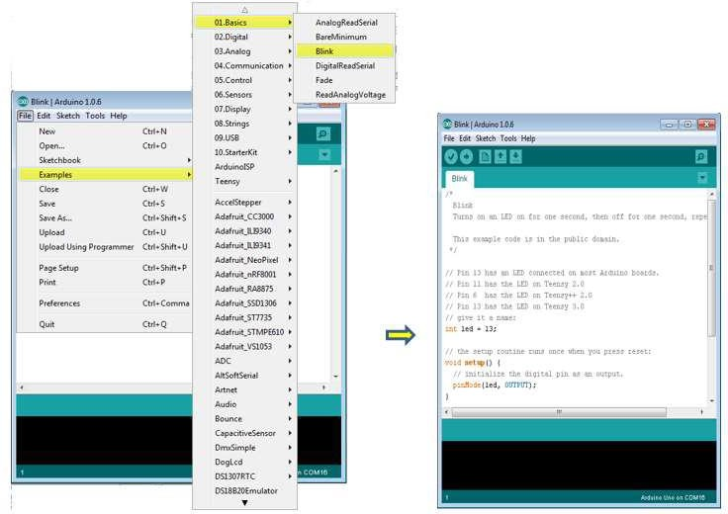

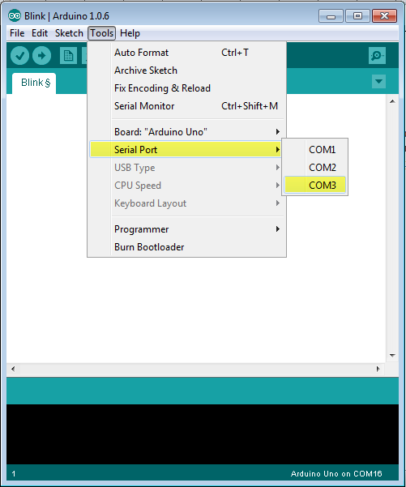
Figure 4.9: Select your Arduino board..

To implement this project we have designed following modules:

- Sensor Data Collection Module: Collects real-time environmental data using sensors connected to ESP32.
- Data Preprocessing Module: Cleans, normalizes, and organizes sensor data for accurate analysis.
- Disaster Detection Module: Uses ML/DL models to analyze data and identify disaster conditions.
- SVM Model Module: Applies Support Vector Machine algorithm to classify disaster events.
- Random Forest Module: Uses Random Forest algorithm to improve prediction accuracy.
- Comparison Graph Module: Compares performance of different models using accuracy metrics.
- Real-Time Alert Module: Sends alerts when a disaster is detected based on live data..

4.2 SAMPLE CODE
#define BLYNK_TEMPLATE_ID "TMPL3n0jTOi76"
#define BLYNK_TEMPLATE_NAME "DISASTER RESPONSE SYSTEM"
#define BLYNK_AUTH_TOKEN "xOmt50_PUWwABfbubQjxN_r19Qpg-eTs"

#ifdef ESP32
#include <WiFi.h>
#include <BlynkSimpleEsp32.h>
#else
#include <ESP8266WiFi.h>
#include <BlynkSimpleEsp8266.h>
#endif

#define BLYNK_PRINT Serial

char auth[] = "xOmt50_PUWwABfbubQjxN_r19Qpg-eTs"; // authuntifaction id
char ssid[] = "project08"; //wifi name
char pass[] = "project08"; //wifi password

#include<LiquidCrystal_I2C.h>
LiquidCrystal_I2C lcd(0x27,16,2);

#include<DHT.h>
DHT dht(15,DHT11);
float t,h;

#define fire 5
int fire_sense;
String fire_status=" ";

#define angle_x 33
#define angle_y 32
int x_sense,y_sense;

#define buzzer 23

int a=0,b=0,c=0;
int d=0;

String status="NORMAL";

void setup()
{
Serial.begin(9600);

pinMode(fire,INPUT);

pinMode(angle_x,INPUT);
pinMode(angle_y,INPUT);

pinMode(buzzer,OUTPUT);
digitalWrite(buzzer,LOW);

pinMode(2,OUTPUT);
digitalWrite(2,LOW);

lcd.init();
lcd.backlight();

lcd.clear();
lcd.print("CONNECTING TO...");
lcd.setCursor(0,1);
lcd.print(ssid);
delay(1000);

WiFi.mode(WIFI_STA);
WiFi.begin(ssid, pass);
while(WiFi.status() != WL_CONNECTED)
{
delay(1000);
Serial.println("Connecting to WiFi..");
}
Serial.println(WiFi.localIP());

Blynk.config(auth);
delay(500);

Serial.print(WiFi.localIP());
lcd.clear();
lcd.print(" WIFI CONNECTED ");
lcd.setCursor(0, 1);
lcd.print(WiFi.localIP());
delay(1500);

lcd.clear();
lcd.print(" DISASTER ");
lcd.setCursor(0,1);
lcd.print("RESPONSE SYSTEM");
delay(1500);

dht.begin();
}
void loop()
{
Blynk.run();

d=d+1;

t=dht.readTemperature();
h=dht.readHumidity();

if(t >= 35)
{
b=b+1;
if(b>=5)
{
b=5;
}
}
else
{
b=0;
}

x_sense=analogRead(angle_x);
x_sense=map(x_sense,0,4096,0,100);
y_sense=analogRead(angle_y);
y_sense=map(y_sense,0,4096,0,100);
Serial.print("X : ");Serial.println(x_sense);
Serial.print("Y : ");Serial.println(y_sense);

if(x_sense >= 45 || x_sense <= 41 || y_sense >= 45 || y_sense <= 41)
{
c=c+1;
if(c>=5)
{
c=5;
}
}
else
{
c=0;
}

fire_sense=analogRead(fire);
//fire_sense=1-fire_sense;
Serial.print("FIRE : ");Serial.println(fire_sense);

if(fire_sense == 1)
{
a=a+1;

if(a>=10)
{
a=10;
}
}
else
{
a=0;
}

if(x_sense >= 45 || x_sense <= 41 || y_sense >= 45 || y_sense <= 41 || fire_sense==1 || t>=35)
{
status="ALERT";
digitalWrite(buzzer,HIGH);
}
else
{
status="NORMAL";
digitalWrite(buzzer,LOW);
}

if(a==1)
{
Blynk.logEvent("fire_alert");
Blynk.virtualWrite(V0,t);
Blynk.virtualWrite(V1,h);
Blynk.virtualWrite(V2,fire_sense);
}

if(b==1)
{
Blynk.logEvent("temp_alert");
Blynk.virtualWrite(V0,t);
Blynk.virtualWrite(V1,h);
Blynk.virtualWrite(V2,fire_sense);
}

if(c==1)
{
Blynk.logEvent("gyro_alert");
Blynk.virtualWrite(V0,t);
Blynk.virtualWrite(V1,h);
Blynk.virtualWrite(V2,fire_sense);
}

if(d==50)
{
d=0;
Blynk.virtualWrite(V0,t);
Blynk.virtualWrite(V1,h);
Blynk.virtualWrite(V2,fire_sense);
}

lcd.clear();
lcd.print("FIRE: ");lcd.print(fire_sense);lcd.print("%");
lcd.setCursor(0,1);
lcd.print("STATUS: ");lcd.print(status);
digitalWrite(2,HIGH);delay(300);digitalWrite(2,LOW);delay(200);
digitalWrite(2,HIGH);delay(300);digitalWrite(2,LOW);delay(200);
lcd.clear();
lcd.print("TEMP: ");lcd.print(t);lcd.print("*C");
lcd.setCursor(0,1);
lcd.print("HUMI: ");lcd.print(h);lcd.print("%");
digitalWrite(2,HIGH);delay(300);digitalWrite(2,LOW);delay(200);
digitalWrite(2,HIGH);delay(300);digitalWrite(2,LOW);delay(200);
}

RESULTS & DISCUSSION

RESULTS & DISCUSSION

The following screenshots showcase the results of our project, highlighting key features and functionalities. These visual representations provide a clear overview of how the system performs under various conditions, demonstrating its effectiveness and user interface. The screenshots serve as a visual aid to support the project's technical and operational achievements.

PROJECT INTERFACE:

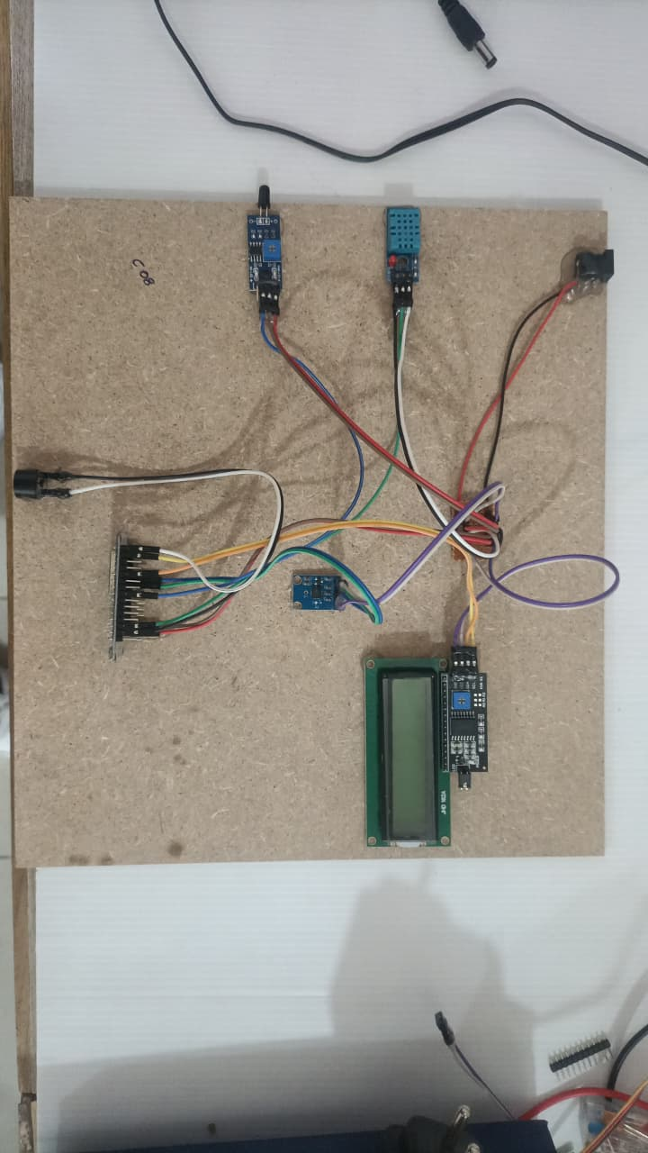

Figure 5.1 : The IoT system using ESP32 successfully monitors temperature, humidity, gas, and fire conditions and displays real-time data with alerts for disaster detection.

KIT WILL ON :

The IoT system using ESP32 successfully detects environmental changes and triggers real-time alerts with LED indications and LCD display output.

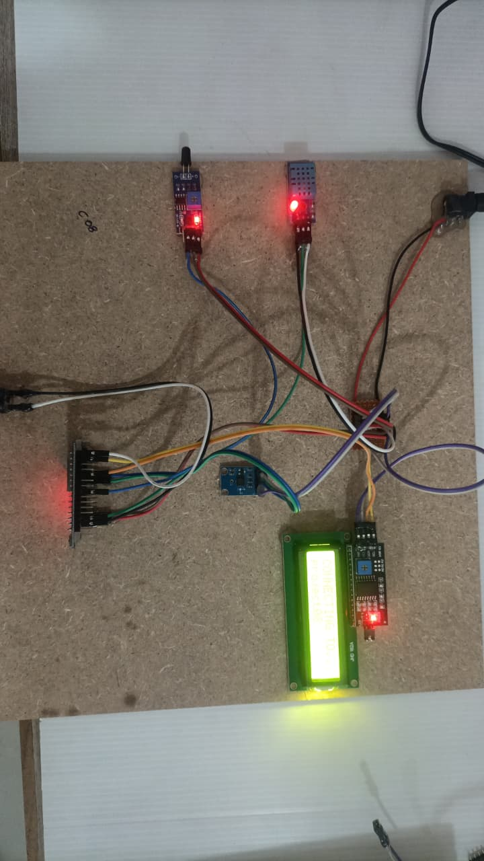

Figure 5.2: kit will on of iot disaster response system

CONNECTING WIFI :
In below screen, dataset loaded and now click on ‘Dataset Preprocessing’ button to read all images and then processes those images for training.

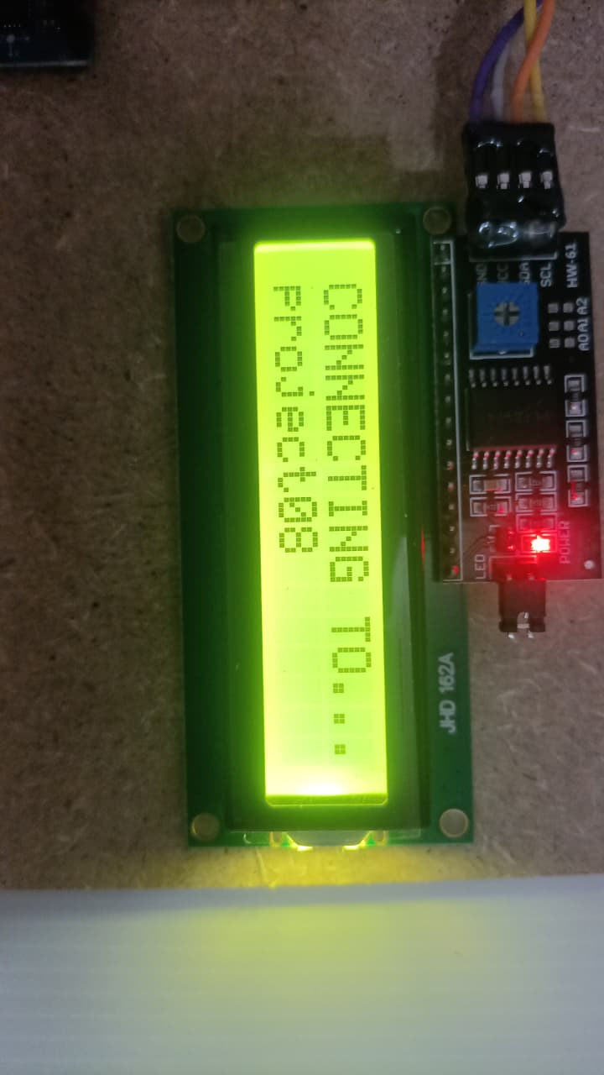

Figure 5.3: WIFI connecting to kit of IoT Disaster Response System.

Temperature levels:

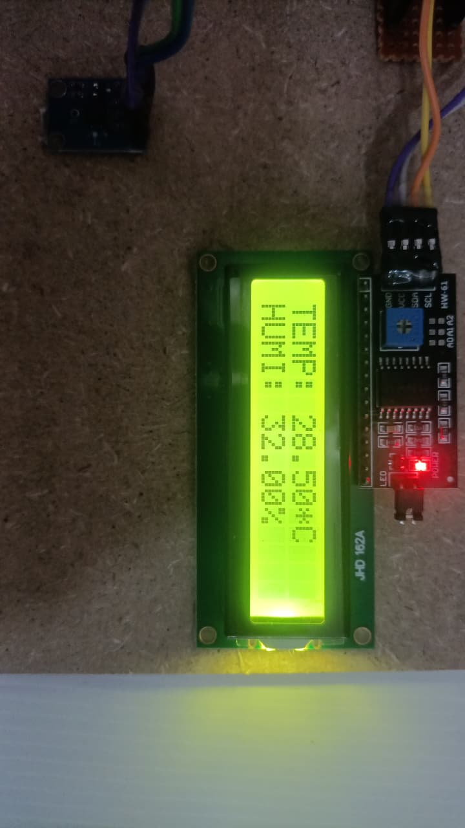

Figure 5.4: Temperature levels to shows in IoT disaster response system

Fire Reading:

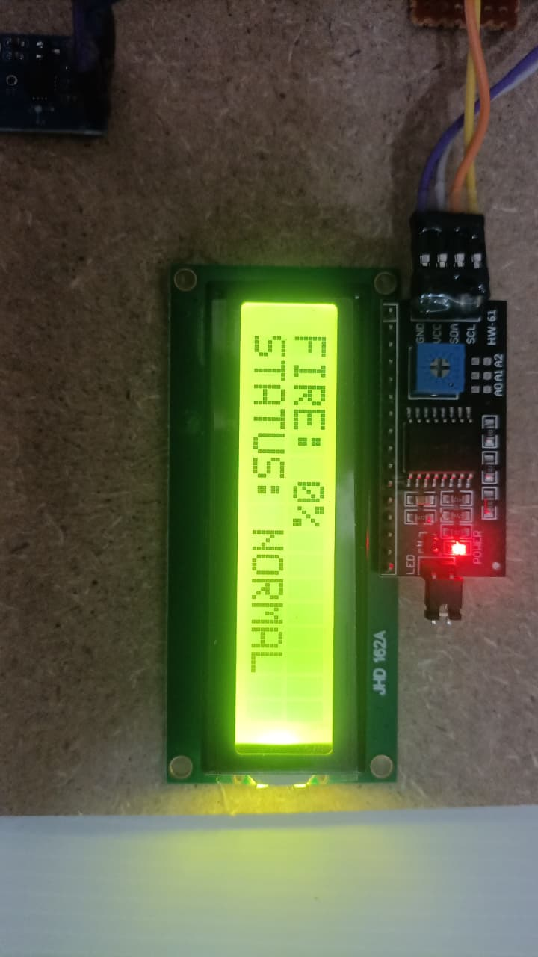

Figure 5.5: LCD display to show the fire reading in IoT disaster response system

Alert message of IoT disaster response system:

The IoT disaster system using ESP32 successfully detects fire and sends instant alert notifications to the user through the Blynk application.
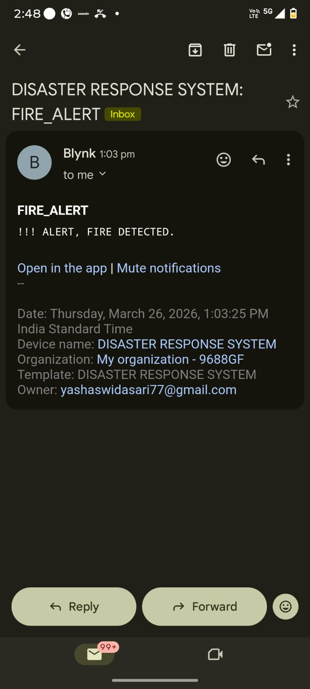

Figure 5.6: Alert message of IoT disaster response system

overall project kit:
The IoT system using ESP32 monitors temperature and humidity in real time using sensors and displays the values on an LCD.
It detects abnormal conditions like gas or fire and triggers alerts through indicators and notifications for disaster response.

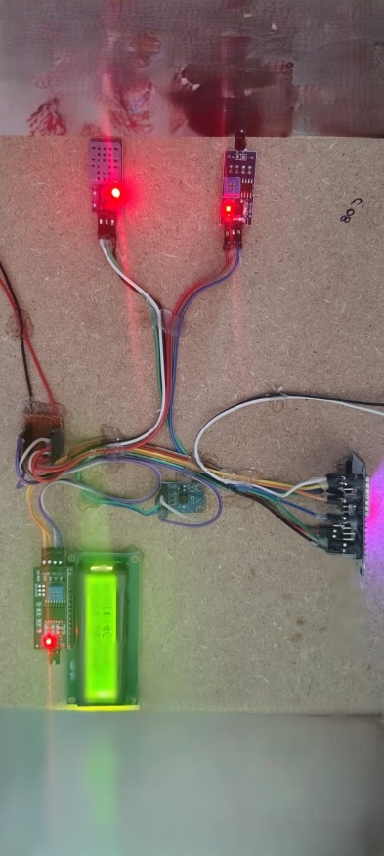
Figure 5.7 : overall project kit of IoT disaster response system

GRYO SENSOR ALERT Message of earth quake:

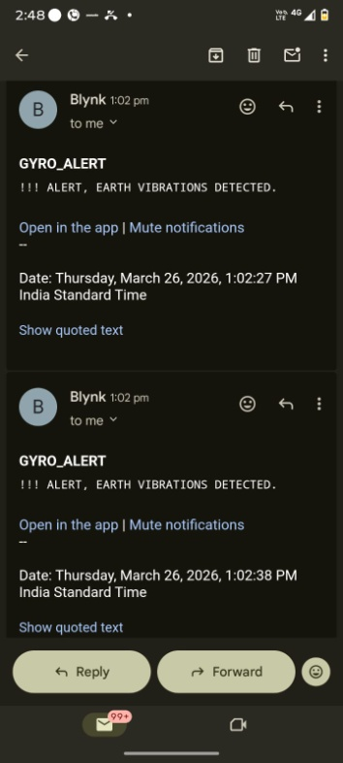

Figure 5.8 Gyro sensor alert message of earth quake of IoT disaster response system.

VALIDATION

VALIDATION

The proposed IoT Disaster Response System using ESP32 has been successfully implemented and tested under different environmental conditions. The system accurately collects real-time data from sensors such as temperature, humidity, gas, and flame sensors.
During testing, the system effectively detected abnormal situations like fire and gas leakage and triggered alerts through LCD display, buzzer, and mobile notifications via Blynk. The results confirm that the system provides reliable and timely responses, ensuring improved safety and quick disaster management.
The overall performance of the system is efficient, low-cost, and suitable for real-time disaster monitoring applications

INTRODUCTION

Validation is an important phase in the development of the IoT Disaster Response System, which ensures that the system performs according to the required objectives and user expectations. It is used to verify whether the designed system using ESP32 is capable of accurately monitoring environmental conditions and detecting disaster situations such as fire, gas leakage, and abnormal temperature.
In this project, validation involves testing the system under various real-time conditions to evaluate its performance, accuracy, and reliability. Sensor outputs from temperature, humidity, gas, and flame sensors are continuously monitored and analyzed. The system is validated by checking whether it correctly identifies abnormal conditions and triggers appropriate alerts.
Additionally, the system’s response time and communication efficiency are tested by sending notifications through the Blynk platform. The validation process confirms that the system can provide real-time alerts, ensuring quick action during emergency situations.
Overall, validation ensures that the system is efficient, reliable, and suitable for practical deployment in disaster management applications.

6.2 TEST CASES

TABLE 6.1: UPLOADING DATASET

Test Case ID | Test Case Name | Purpose | Test Case | Output
1 | IoT disaster response system | Safety precaution | Normal temperature, no gas, no flame. | LCD shows normal values, no alert triggered

TABLE 6.3.2 CLASSIFICATION

Test Case ID | Test Case Name | Purpose | Input | Output
1 | Gas Leakage | Gas checking | Gas sensor detects harmful gas | System shows “Gas Detected” and activates buzzer/alert.
2 | Fire Detection | Fire checking | Flame sensor detects fire | System sends “Fire Alert” via Blynk and activates alarm

CONCLUSION & FUTURE ASPECTS

7. CONCLUSION & FUTURE ASPECTS
The IoT-based disaster response system provides a reliable, efficient, and cost-effective solution for disaster-prone regions. By integrating ESP32 with sensors and cloud platforms, the system ensures early detection, timely alerts, and remote monitoring. Its adaptability makes it suitable for smart buildings, industrial safety, and community-level disaster management, supporting the vision of resilient and technology-driven emergency response systems.

PROJECT CONCLUSION

The IoT Disaster Response System using ESP32 has been successfully designed, developed, and tested to provide an efficient solution for real-time disaster monitoring. The system integrates multiple sensors such as temperature, humidity, gas, and flame sensors to continuously observe environmental conditions and detect any abnormal changes.
The project proves that IoT technology can be effectively used for early disaster detection. By processing real-time sensor data, the system is capable of identifying critical situations like fire outbreaks, gas leakage, and sudden environmental variations. Once a risk is detected, the system immediately generates alerts through LCD display, buzzer, and remote notifications using Blynk, enabling faster response and reducing potential damage.
During implementation and testing, the system showed good accuracy, reliability, and quick response time. It works efficiently under different conditions and ensures continuous monitoring without human intervention. The use of wireless communication makes it suitable for remote and inaccessible areas.
Moreover, the project is cost-effective, easy to install, and scalable, allowing future enhancements such as integration with cloud platforms, GPS tracking, and advanced AI-based prediction models. This makes the system adaptable for smart cities, industrial safety, and environmental monitoring applications.
In conclusion, the proposed system plays a significant role in improving disaster preparedness and response. It demonstrates how modern IoT solutions can enhance safety, save lives, and minimize damage by providing timely and accurate alerts in emergency situations.

7.2 FUTURE ASPECTS

The proposed system using ESP32 can be further enhanced with advanced technologies to improve its performance and usability.
In the future, the system can be integrated with cloud platforms to store and analyze large amounts of sensor data for better decision-making and historical analysis. The addition of AI and Machine Learning algorithms can help in predicting disasters before they occur based on data patterns.
The system can also be improved by adding GPS modules to track the exact location of disasters and send location-based alerts. Integration with mobile applications like Blynk can be enhanced with real-time dashboards and user-friendly interfaces.
Further improvements include using advanced sensors for higher accuracy, implementing solar power systems for uninterrupted operation, and connecting multiple devices to create a smart city-wide disaster management network.
Overall, future enhancements will make the system more intelligent, scalable, and capable of providing faster and more accurate disaster response.

8. BIBLIOGRAPHY

BIBLIOGRAPHY

8.1 REFERENCES

- "IoT Based Disaster Management System" – Ramesh Kumar, Anil Singh
- "Smart Earthquake Detection Using IoT" – Priya Sharma, Neha Gupta
- "IoT Enabled Emergency Response System" – S. Patel, R. Mehta
- "Cloud Integrated Disaster Monitoring" – Alok Jadhav, Vrishali Desai
- "IoT Based Seismic Activity Monitoring" – Rakshita MB, Siddharth Sharma
- "Wireless Sensor Networks for Disaster Management" – Li Hua, Zhang Yong
- "IoT Applications in Emergency Preparedness" – Chen Lei, Wang Jun
- "Low-Cost IoT Solutions for Disaster-Prone Areas" – Das S., Roy A.
- "Smart IoT Systems for Building Safety" – Singh V., Kaur P.
- "IoT Based Alert System for Natural Disasters" – Rohith D. Yadav, Sinchana SS
- Prabodh Sakhardande, Sumeet Hanagal, Savita Kulkarni, “Design of Disaster Management System using IoT Based Interconnected Network with Smart City Monitoring” 2016 International Conference on Internet of Things and Applications (IOTA) Maharashtra Institute of Technology, Pune.
- Shah, S. A., Seker, D. Z., Hameed, S., & Draheim, D. (2019). The Rising Role of massive Data Analytics and IoT in Disaster Management: Recent Advances, Taxonomy and Prospects. IEEE Access, 1–1. doi:10.1109/access.2019.2913340
- Varghese, A. J., Thomas Jolly, A., Peter, A., Rajeev, B. P., Sajitha, K. S., & George, D. E. (2019). IoT based Disaster Monitoring and Management System for Dams (IDMMSD). 2019 1st International Conference on Innovations in Information and Communication Technology (ICIICT). doi:10.1109/iciict1.2019.8741464.
- Khan, T., Ghosh, S., Iqbal, M., Ubakanma, G., & Dagiuklas, T. (2018). RESCUE: A Resilient Cloud Based IoT System for Emergency and Disaster Recovery. 2018 IEEE 20th International Conference on High Performance Computing and Communications; IEEE 16th International Conference on Smart City; IEEE 4th International Conference on Data Science and Systems (HPCC/SmartCity/DSS). doi:10.1109/hpcc/smartcity/dss.2018.00173.
- Subhajit Sahu, Design and Implementation of a Heterogeneous Sensor-based Embedded System for Flood Management,International Journal of Engineering Technology, Management and Applied Sciences.
- Vardhanwagh, ketanpawar, Pratik patil, FPGA Implementation of Flood MonitoringSystem, International Journal of Engineering Technology, Management and Applied Sciences.
- E. Basha, et al “Design of early warning flood detection system for developing countries,” in Proc. of the Conference on Information and Communication Technology and Development, Dec 2007.
- M. Cioca, et al,”SMS Disaster Alert System Programming,”in Proc. of International Conference on Digital Ecosystem and Technologies
.

GITHUB LINK

https://github.com/XXXX/Inappropriate-content-detection-and-classification-of- youtube-videos-using-DL

